Module 4:

Creating Task Relationships

Contents

Module Overview 1

Lesson 1: Automatic vs. Manual Scheduling 2

Scheduling Overview 3

Automatic v Manual Scheduling 4

When to Use Manual vs. Automatic Scheduling 6

Setting Scheduling Option 8

Adjusting Tasks in Manual Mode 11

Practice: Working with Automatic and Manual Scheduling 13

Lesson 2: Working with Dependencies 14

Task Dependency Types 15

Best Practices for Using Dependencies 19

Creating and Viewing Dependencies 23

Practice: Working with Dependencies 27

Lesson 3: Understanding Leads & Lags 28

What is Lag Time? 29

What is Lead Time? 31

Best Practices 33

Practice: Working with Leads and Lags 34

Summary 35

4

.

# Module Overview



After the work (tasks) for a project has been established, the scheduling process begins. Project 2010 allows for two scheduling methods: Manual and Automatic scheduling. These methods may be used separately or in combination. Task dependencies will be needed to help establish the order the tasks will be scheduled. Lead and lag features may be used to help fine tune the timing of the schedule.

After completing this module, you will understand:

1. Automatic vs. Manual Scheduling
2. Sequencing
3. Predecessors and Successors
4. Lead and Lag Time

# Lesson 1: Automatic vs. Manual Scheduling



Project 2010 introduces the choice of manual scheduling in addition to the traditional automatic scheduling used in prior Project software versions. Each option has its strong points and drawn backs and the scheduling choice is generally dependent upon personal preference of the user. This lesson provides deeper details about automatic and manual scheduling. Understanding each scheduling method and its consequences will help achieve a more accurate and reliable project timeline.

After completing this lesson you will understand:

1. Overview of Scheduling
2. Automatic v Manual scheduling features
3. When to use automatic vs. manual
4. Setting scheduling options

## Scheduling Overview



Project 2010 provides two scheduling methods for creating project schedules. The methods are the traditional or automatic scheduling and manual scheduling.

**Traditional or automatic scheduling:**

This scheduling method was used in prior versions of MS Project and is contained in Project 2010. After tasks are entered relationships or dependencies are created between the tasks. The task durations with their relationships established the timeline for the schedule. This scheduling method allows for bottom up scheduling where the sum of the detail tasks establishes the time line for the project.

**Manual scheduling:**

Manual scheduling allows for top-down scheduling where summary tasks may be added first and the details of the project work is completed later. It also permits more unknowns during scheduling process and the ability to complete the details when known. Tasks do not have to contain relationships and scheduling dates may be entered.

Project scheduling mode will be selected on a task by task basis. Manually scheduled tasks and automatic scheduled tasks may be mixed within the same project schedule. Each task will contain a column called *task mode* which will establish the scheduling mode assigned to a task.

## Automatic v Manual Scheduling



Whether you use Manual or Automatic scheduled tasks or a combination of both is a personal scheduling preference. Below are some of the capabilities of these scheduling modes to help you determine which method will work best for you. Projects should be looked at on a project by project basis and select the scheduling method best suited to the individual tasks and project.

|  |  |  |
| --- | --- | --- |
| **Features for scheduling tasks** | **Manual scheduling** | **Automatic scheduling** |
| Only valid values may be entered into standard fields (duration, start, finish, etc) | Unique text values may be entered into fields such as duration, start, finish, etc.  If the task mode is changed to Automatic, valid field values will replace unique text values | Yes |
| Calculate project duration based on task relationships | Yes | Yes |
| Task may be tracked, re-scheduled and may have a baseline | Yes | Yes |
| Tasks can have estimated baselines | Yes | No |
| Possible scheduling issues will result in warnings for potential scheduling issues | Yes | No |
| Tasks will be scheduled based on resource availability and the assignment of the resource to the task | No | Yes |
| Tasks will dynamically react to duration and date changes. | No | Yes |
| Project Calendar non-working time will be honored during task scheduling. | Yes | Yes |
| Resource leveling | No | Yes |
| Task types are enforced | No | Yes |
| Changing the project start date will re-schedule the project tasks to the new date | No | Yes |
| Task constraints may be assigned | No | Yes |
| Placeholder tasks (task name only without task details) is allowed | Yes | No |
| Enter values (duration, start, finish, etc) into summary tasks | Yes | No – summary tasks are calculated subtotals |
| Summary task values (duration, work, cost) roll up the sum of the member detail tasks | No – manual entries could be made on the summary tasks which are different than the detail task values  If summary task is changed to automatic scheduling, summary totals will replace entered values | Yes |
| Schedules will be able to calculate a critical path | Yes | Yes |

Note: *formatting for manual tasks v automatically schedule tasks will appear different on the Gantt Chart. Manually scheduled have a variety of format indicators used as the result of different scheduling entries.*

## When to Use Manual vs. Automatic Scheduling



Manual vs. automatic scheduling usage is a personal preference. The project manager’s schedule management expectations, experience and goals will be included when deciding to use one method over the other. The amount of information concerning the project that is available to the scheduler when the schedue is created should also be taken into consideration. It may be advantageous to use both scheduling methods within a schedule switching between scheduling methods when needed.

**Use Manual scheduling when:**

* Minimal information is available about the project and you need to put your ideas into an initial schedule.
* Tasks are assigned to specific dates and you are not comfortable with the schedule moving as other tasks are entered or as resources are assigned.
* Using top-down planning – entering duration values for summary tasks followed by detail tasks and milestones to complete the work of the summary tasks.
* Using free form planning of tasks and durations to produce a Gantt chart.
* Need to build a rough schedule for a future project
* Relationships are not known.
* Manual scheduling is your most preferred method. Enter as many durations, relationships and dependencies as you need to help establish the timeline. This will help with critical path calculation as well.

**Use Automatic scheduling when:**

* More complete information is known about the goals of the project.
* Using bottom up planning. Enter the summary tasks names only. The detail tasks within the summaries will calculate the duration of the summary tasks.
* You want the schedule to be dynamic. Tasks will be re-scheduled based on work completed and associated dependencies. The scheduling engine will help keep you on track for the project and help you manage to an end date.
* You want the scheduling engine to calculate dates in the schedule.
* Resource allocations, earned value and more accurate metrics are needed.

**Consider using a combination of both methods when:**

* Initial planning could be in manual mode. As decisions are made and more detail is known, tasks may be converted to automatic mode.
* Consider converting to automatic mode when project execution begins. This may be done for the entire project, by phase or range of tasks.

**Project files from earlier Project versions:**

* When Project 2010 opens projects schedules created in earlier versions tasks will be locked in automatic mode and the mode can not be altered unless they are upgraded to a Project 2010 file.
* Saving the file with a new name converts the file to a Project 2010 file and theautomatic/manual mode option becomes available.
* The Type Mode field might not be visable when opening projects of earlier versions. When attempting to insert the Task Mode column into a table, the column will not be available.

## Setting Scheduling Option



The column or field in Project 2010 that determines which scheduling mode a task will be scheduled by is called “Task Mode”. By default, you will see this field on the Entry table of the Gantt Chart. This column may be added to any task table.

Setting the automatic or manual scheduling mode may be accomplished in several ways:

**To set the scheduling mode for a project or for all future projects:**

* **File** 🡪 **Options** 🡪 **Schedule**

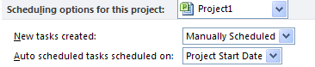

After several tasks are entered you may decide to switch to a different scheduling mode for the addition of future tasks for the project. This can be done quickly using the choice option at the bottom left hand corner of the Gantt Chart view which is shown below. Changing this option will not affect existing tasks in the schedule; it will only affect future added tasks. Click on the button highlighted below for the option to change scheduling modes:

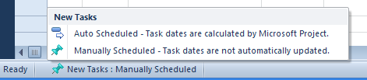

The default Entry Table for the Gantt Chart includes the “Task Mode” column inserted to the left of the Task Name column. This column may be inserted into any table as needed.. The indicators in this column indicate the scheduling mode for the task. In the view below the automatically scheduled tasks have a  icon and the manually scheduled tasks have a  icon in the Task Mode column. Hover your mouse pointer over the icon and the scheduling mode description will appear. Clicking on the icon will allow for scheduling mode changes per task. Note the different Gantt bar formats for manual v automatically scheduled tasks.

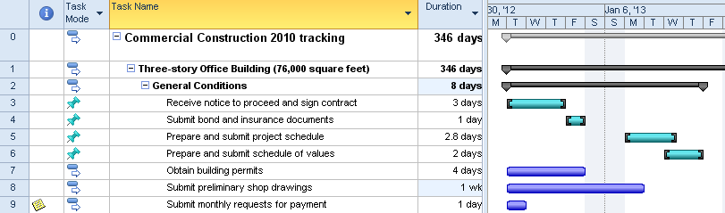

**To change the scheduling mode from the Task ribbon:**

* Click task to be changed
* Click **Task 🡪 Manual Schedule** or **Automatic Schedule**

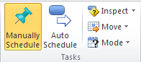

Another way to change the schedulig mode is to double clicking a task to open the Task Information dialogue box. An option is located on the General tab to change the scheduling mode. The options are highlighted in the view below.

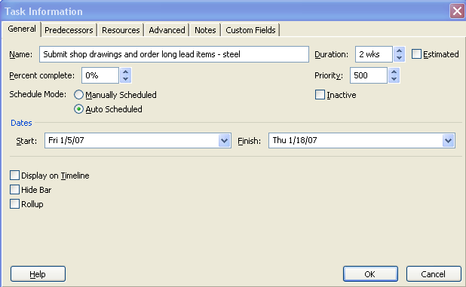

## Adjusting Tasks in Manual Mode



Tasks in Manual mode are very free form. They can be easily moved or adjusted. Several warnings are built into tasks to alert the user of possible scheduling errors. Formatting will vary when entering a task in Manual mode depending on what the user is doing or what has been done to the task.

**To enter a manually scheduled task:**

Type the task name in the Task Name field and click Enter. In the view below note that the duration, start and finish fields are blank and no Gantt bars appear. This is a place holder task which can be used when task details are not known. Note that the Task Mode indicator has a “?” in the symbol indicating that the information for the task is not completed.



Text may be entered in fields that usually hold duration, work, dates, etc. to help during the planning process.



When a duration value is entered in the duration field, a Gantt bar will appear and will extend for the duration entered. Note the formatting of the Gantt bar is different than an automatically scheduled task. The formatting has been altered as a way of indicating task scheduling differences.



After entering a start date Project 2010 will calculate an end date. Notice the format of the Gantt bar for the task has changed and the “?” symbol has disappeared from the task mode icon.



If only a start date is known for a task, it may be entered and the Gantt Chart will appear as below.



Or, if a finish date is known for the task it may be entered and the Gantt chart will appear as below.



Warnings will be displayed by Project 2010 if the manual timing of tasks is questionable. Below is an example of a warning for a manually scheduled task. The error shown below occurred when the value of the duration of the summary task is less than the value of the detail task durations below. The summary task error is represented as a red bar to show what the length should be for the summary task and dots appear around the violating detailed task Gantt bars.

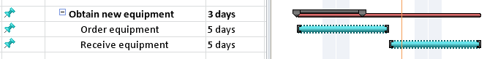

## Practice: Working with Automatic and Manual Scheduling



*The Practice page is where you write detailed instructions for completing work listed as Exercises.*

*Type the Exercise Title and write a brief summary what the student will be doing in the exercise. Then list your ideas what they will be doing.*

*SAMPLE*

*In this practice you will create a Project Server Authentication profile and then configure the local cache settings in Project Professional 2007.*

*Exercise 1: Create Project Server Authentication Profile*

*In this exercise you will create Project Server authentication profile to connect to the Project Web Access site.*

Perform the following exercise on the PS07 virtual machine.

1. *From the* ***Start*** *menu, click* ***All Programs*** *🡪* ***Microsoft Office*** *🡪* ***Microsoft Office Tools*** *and click* ***Microsoft Office Project Server 2007 Accounts****.*
2. *In the* ***Project Server Accounts*** *dialog box, click* ***Add****.*
3. *In the* ***Account Properties*** *dialog box, and complete the following settings and click* ***OK****.*

|  |  |
| --- | --- |
| *Setting* | *Perform the following:* |
|  | |
| *Account Name* | *Type* ***Project Server*** |
| *Project Server URL* | *Type* ***http://epm/pwa*** |
| *When connecting* | *Select* ***Use Windows user account*** |
| *Set as default account* | *Select check box* |

# Lesson 2: Working with Dependencies



Once the tasks are entered in to the project schedule, the next step is to consider in what order the tasks should be performed. Many tasks will have a flexible order and others will have a forced order of performance. Establishing the order of the tasks is one of the factors that will help calculate the timeline of the project schedule. A dependency is the name given to the relationship established between the tasks used to establish the order of tasks. If dependencies are not created, Project 2010 will not be able to accurately predict and adjust dependent future tasks based on completed work.

**In this lesson we will discuss:**

1. Dependency types
2. Best practices using dependencies
3. Creating and viewing dependencies

## Task Dependency Types



Project 2010 allows for 4 types of task dependencies. These dependencies establish the order that the tasks will be performed. Dependencies may also be referred to as links, relationships or relationships between tasks. The result of creating task relationships is a network of related tasks establishing a time line. When referring to linked tasks the following terms will apply:

* A task that has a relationship directly before a task is known as a *predecessor* task
* A task that has a relationship directly after a task is known as a *successor* task

In the view below there are 4 tasks. The relationships are established as link lines between tasks.

* The predecessor task or task that comes before Task B is Task A.
* The successor task or task that comes after Task B is Task C.

Pointing to a link line between tasks will reveal information regarding the relationship between tasks. See the highlighted box below which is showing the details of the relationship between Task C and Tack D.

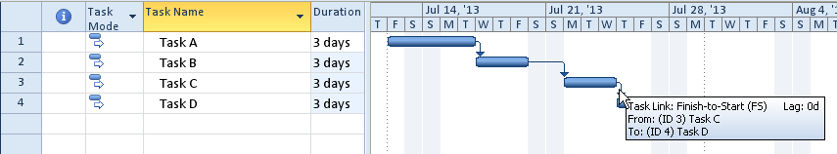

Not all dependencies are the same. Some tasks will start at the same time where others might be schedule one after the next. To facilitate scheduling needs, there are 4 dependency types which are:

* Finish-to-start
* Start-to-start
* Finish-to-finish
* Start-to-finish

The details of each of the relationship types is described below:

* **Finish-to-Start (FS)**
  + Default dependency for the Project 2010
  + Task 1 must complete before Task 2 can begin
  + This relationship type creates a waterfall effect  
    - Example: Drive to the restaurant, then eat dinner  
       Build a wall then paint the wall

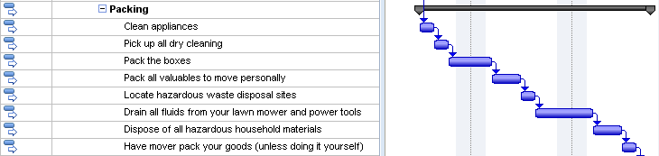

* **Start-to-Start (SS)**
  + Tasks that are scheduled to start at the same time  
    - Example: After the moving expenses are calculated, then determining the best moving method, create a moving-expenses file and create a moving binder may all start at the same time. All 3 tasks should be completed (in this example) to pass the milestone and move on to the next section of work. It should also be noted that the 3 tasks that are starting at the same time are not scheduled to complete at the same time. As a result, the longest task will determine when the milestone will be scheduled.

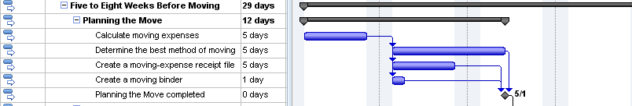

* **Finish-to-Finish (FF)**
  + Tasks that are scheduled to finish at the same time but not required to start at the same time.
    - Example: The section of work below can all start when the previous section is completed. These tasks will start at different times, but they all need to be completed by the same point in time.

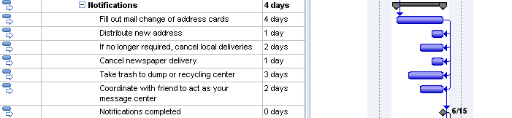

* **Start-to-Finish (SF)**
  + The start date of the predecessor task will determine the finish date of the successor task.
  + This is the least used dependency type and rarely used.
  + Example: When the new software module comes on line, the old software will be taken off line



NOTE: When working with manually scheduled tasks, errors might result using dependencies. A warning is viewed when tasks are linked and dates are entered into the start or finish columns. The calculation of the project duration might not match the duration calculated when the entered dates are taken into consideration. Below is an example of an error created when a date was entered in the start column for Task B. The error is represented by the red line under the incorrect date and the dots around the Gantt bars.

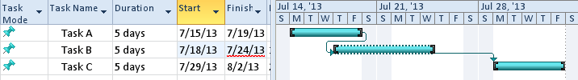

To correct this type of error, Project 2010 has a new feature called Respect Links. Right click on the red error line and following choices appear. Select the Respect Links option and the date will be recalculted based on the task relatioships.

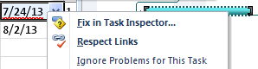

Below is the result of clicking on the Respect Links option for the task. Note the error message is no longer visable and the task in error has been rescheduled.

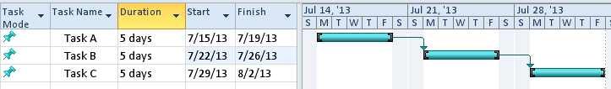

## Best Practices for Using Dependencies



Project 2010 calculates the duration of a project based on how task dependencies are created between tasks. Establishing the order of the tasks is called Sequencing. Sequencing is concerned with establishing the order tasks should or could be performed. Arranging tasks in the most efficient order for the project is not an easy exercise. Sometimes, the order of the tasks is very evident and at other times, more complicated. Sequencing is more option than right or wrong for a project.

For example, the following tasks are tasks that someone would do when they come home after work and before they go to bed:

1. Arrive Home
2. Eat Dinner
3. Walk the dog
4. Run an errand
5. Read the mail
6. Clean up the dinner dishes
7. Cook dinner
8. Go to Sleep
9. Get the mail
10. Watch the news

Take a minute to write down the numbers of the tasks above in the order you would perform these tasks.

Things you might notice:

* You will have some forced relationships:
  + You can’t eat dinner until you make dinner
  + You can’t read the mail until you get the mail
* You will also notice that Arrive Home and Go to Sleep are the start and finish of the sequence.
* Some tasks can occur at any time and are not dependent upon another tasks
* Some tasks you might consider doing differently, like picking up dinner on the way home. It would accomplish the same purpose and save time.
* Can any tasks be done at the same time as other tasks to save time?
* Should any tasks be eliminated?

Next rework this same sequence of tasks knowing that someone else will help perform the tasks. Does it turn out differently? Would it take less or more time? Some tasks you have to do yourself and some tasks can be performed by someone else.

**Best practices to consider when creating dependencies:**

Relationship between tasks will allow you to create network of related tasks. The network will show order the tasks will occur. Below are some best practices which should be considered when creating relationships:

* All tasks should have both a predecessor and a successor. The timeline for the project is based on this concept. If tasks are not linked in the network of tasks, their duration will not be accounted for within the timeline. Making sure all task durations are accounted for will avoid surprises at the end of a project.
* When creating dependencies or relationships, apply the rule – *because I can, is it a good idea?* Do not link every task to every other task. In the example above, should you should have linked Arrive Home with Go to Sleep with the logic of if you don’t come home, you can’t go to sleep? The answer is no. Only the last task that is completed before Go to Sleep should be linked to Go to Sleep.
* Think about what task pushes or influences another task. If a task is late, what other tasks will be affected? Link only tasks with a direct affect on a successor task. Ask yourself what needs to be completed before you can do the next step and if it is late, which tasks will be affected.
* Link detailed tasks and milestones only. The completion of tasks will push the milestones or the short term goals. Linking summary tasks means that an entire section of work must be completed before the next section may be started. Ask yourself if that is true for your situation before linking at the summary level. Linking summary tasks is not recommended.
* Tasks should always be linked to push milestones. For example: define what the definition of “project completed” is. The multiple parallel paths that must be completed to conclude the project should all be linked to the ending milestone. If any of the parallel paths take longer than planned, the milestone date will be pushed out in time.  
    
  In the example below “Start the Project” is the starting milestone. The next 3 sections of work all start when the project starts. All 3 sections must be completed before the house is ready to sell. If any of the sections take longer, each section has the ability to push the ending milestone or when the house is ready to sell. The longest of the parallel paths will be considered the critical path or the section that determines the timeline of the project.   
    
  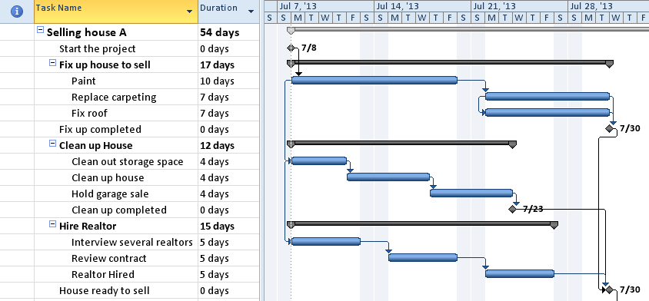
* Create as many parallel paths as possible to shorten the schedule. Use of the Start-To-Start and Finish-To –Finish relationships will help create parallel paths and shorten the project time line. Be aware, however, just because you can schedule tasks in parallel, you might not have the resources to perform the work and which could extend the timeline.
* Do not link tasks based on a resource. Some people will plan tasks to occur at specific times because they think that a resource will be available at that time. Chances are the expected resources will not be available at the planned point in time because other tasks for that resource have changed. Plan the schedule for the work required and plan/arrange for required resources as the time draws nearer to when the task will be performed.
* Links may be external to the project. Project 2010 will allow dependencies to exist in other projects that are linked to tasks in your project. This is similar to links in Excel. In Excel, if links between files are created and the files are relocated, the links will be broken. Project 2010’s links between project files will work the same way.

**NOTE:** Project 2010 also offers the option for tasks that are moved or added to the schedule to automatically link in a Finish-to-Start relationship or not be linked at all. This is a personal preference and may be applied to a specific project or all projects viewed on your desktop.

To view or change this option: **File 🡪 Options 🡪 Schedule**

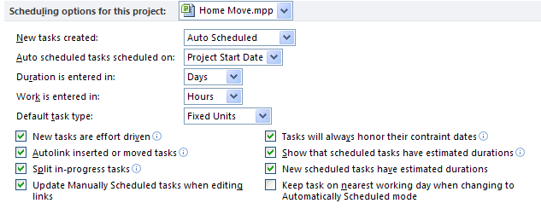

## Creating and Viewing Dependencies



There are many ways to create, delete and modify a dependency. The most common methods will be discussed here. Information concerning additional methods to create dependencies may be found in the help function of Project 2010.

To create a default dependency of Finish-To-Start between 2 tasks or multiple tasks:

* For consecutive tasks:
  + Drag select tasks
  + Click **Task 🡪** **Link**

OR

* For non-consecutive tasks:
  + Click on a task name
  + Press and hold CTRL key
  + Click on the task(s) you would like to link to
  + Click on **Task** 🡪 **Link** 

The Finish-To-Start relationship created will look like this:

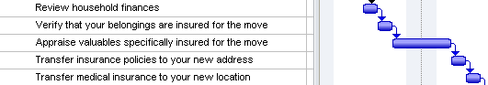

To delete a dependency between 2 tasks or multiple dependencies:

* For consecutive tasks:
  + Drag to select tasks to be deleted
  + Click on Task 🡪 Unlink tasks 

OR

* For Non-consecutive tasks:
  + Click on a task name
  + Press and hold CTRL key
  + Click on the task(s) you would like to unlink
  + Click on **Task 🡪 Unlink** tasks

To alter a Finish-to-Start relationship to another dependency type:

Double click the dependency arrow between tasks.

The Task Dependency dialog box will appear as shown below. Click the down arrow for the Type field and the selections below will appear. Using this box it is easy to alter the dependency type. Hidden under the Type choices in this box is also a Delete option which can be used to delete a dependency.

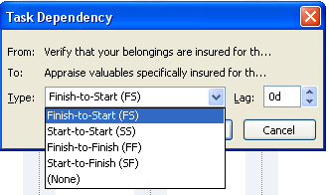

.

Hovering your mouse pointer over a link line will describe the data concerning the relationship between tasks as seen in the diagram below.

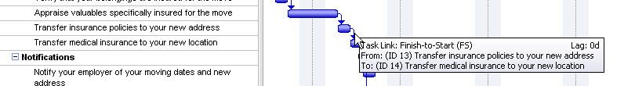

The predecessor column will also become a very important column of information concerning relationships. Above we discussed selecting tasks and linking them. What if the tasks cannot be viewed on the same screen? How would we link the tasks?

In the example below, task number 11 “Verify that your belongings are insured for the move” is the Predecessor or the task that comes before task number 12 “Appraise valuables specifically insured for the move”. The number 11 is in the Predecessor column for task 12. When the predecessor column shows numbers only, it is assumed that the relationship is the default Finish-To-Start relationship. Other relationships will be shown as SS, FF or SF to the right of the predecessor number.

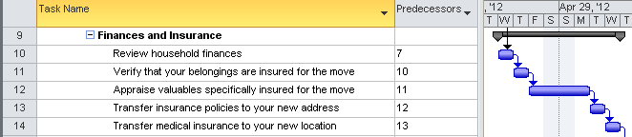

The following diagram is an example of a more complicated dependency. In this example task 91 “Distribute new address” has a predecessor of task 90 using a Finish-To-Finish relationship. Dependencies may also be created or altered by entering or changing the number of the task directly in the Predecessor field. Multiple predecessors may be entered using commas between numbers.

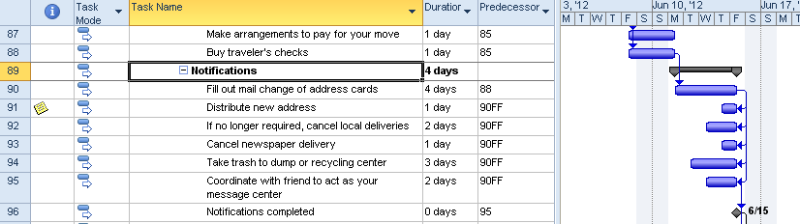

NOTE: *Tasks can have more than one predecessor and more than one successor.*

After the network of tasks has been created, consider looking at the Network Diagram. The best way to get a bird’s eye view of your project is to look at the print preview of the Network Diagram. The Network Diagram shows the result of how predecessors and successors are connected within a project. It will be easy to tell where relationships are missing and relationships that are not what you expected. More information regarding the details of the symbols on the Network Diagram can be found by clicking Format 🡪 Box Styles while in the Network Diagram view. The Help function of Project 2010 is another source for information.

To reveal the Network Diagram in print preview mode:

* Click **Task** 🡪 **Gantt Chart** 🡪 **Network Diagram**
* Click **File** 🡪 **Print**
* Click the Multiple Pages button in the lower right corner of the view

Below is a view of the Network Diagram

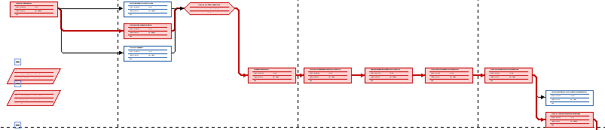

## Practice: Working with Dependencies



*The Practice page is where you write detailed instructions for completing work listed as Exercises.*

*Type the Exercise Title and write a brief summary what the student will be doing in the exercise. Then list your ideas what they will be doing.*

*SAMPLE*

*In this practice you will create a Project Server Authentication profile and then configure the local cache settings in Project Professional 2007.*

*Exercise 1: Create Project Server Authentication Profile*

*In this exercise you will create Project Server authentication profile to connect to the Project Web Access site.*

Perform the following exercise on the PS07 virtual machine.

1. *From the* ***Start*** *menu, click* ***All Programs*** *🡪* ***Microsoft Office*** *🡪* ***Microsoft Office Tools*** *and click* ***Microsoft Office Project Server 2007 Accounts****.*
2. *In the* ***Project Server Accounts*** *dialog box, click* ***Add****.*
3. *In the* ***Account Properties*** *dialog box, and complete the following settings and click* ***OK****.*

|  |  |
| --- | --- |
| *Setting* | *Perform the following:* |
|  | |
| *Account Name* | *Type* ***Project Server*** |
| *Project Server URL* | *Type* ***http://epm/pwa*** |
| *When connecting* | *Select* ***Use Windows user account*** |
| *Set as default account* | *Select check box* |

# Lesson 3: Understanding Leads & Lags



Relationships between tasks are not always absolutely defined as described with relationships. Allowing for Lead and Lag time will help refine a schedule to bring it more in line with the actual timeline for the project. Lead and Lag time will allow for wait time between tasks and overlap of task activities.

In this Lesson we will discuss:

1. What is Lag time?
2. What is Lead time?
3. Best Practices for using Lead and Lag time

## What is Lag Time?



Lag time is used to provide wait time between tasks. The time will be expressed in business days or valid project calendar working time. Lag time should be used to extend the timeline of the project when only duration needs to be added to a schedule and will not add work or cost. For example: New concrete is poured and you must wait 6 days before you can drive on it. The time must occur but no work or cost is added to the task. A dependency must first exist between tasks before Lag time can be created.

**To create Lag time:**

Double click the relationship line between tasks where you would like to add the lag time. The task dependency dialog box below will appear. In the illustration below, we see that there are 2 tasks. After the equipment is ordered there will be a 2 week delivery wait time before the equipment is received. To create this wait time, set the Lag field to 2w (2 weeks). Click **OK**.

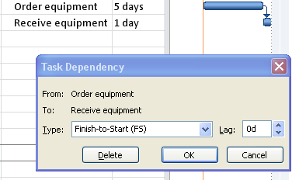

The result is of adding a 2 week lag shown in the illustration below.



An alternate method of entering lag time is by adding the value of the lag into the predecessor column as shown below:

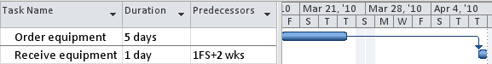

Lag time may also be expressed as a percentage of the duration of the predecessor task. Order equipment is a 5 day task. 50% Lag would mean that the length of the lag time would be 2.5 days or half of the 5 days duration of the Order equipment task.

## What is Lead Time?



Lead time shortens the time line of the project. Consider tasks that do not need to be 100% completed before the successor task can start. Lead time is a good tool to help refine the schedule when trying to cut time from a timeline. Project 2010 does not have a field or box called Lead time. Instead, to create Lead time negative Lag time is entered.

**To create Lead time:**

The diagram below allows 10 days to unpack equipment and 10 days to set up the equipment. The same resources are performing both tasks. The 2 tasks together will require 20 days to complete if the equipment was set up after all of the equipment has been unpacked. If you had more resources to work on the tasks could you get these tasks accomplished quicker? In the example below the task to set up equipment will be scheduled to start when the equipment is half unpacked.

Below is a view of the tasks before lead time is entered. The tasks are scheduled for 20 days of duration.

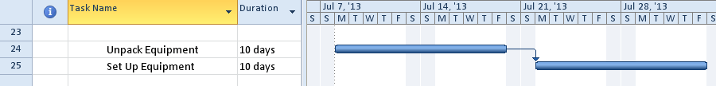

To enter Lead time between two tasks:

* Double click the relationship line between tasks where lead time is to be added.
* Enter “-5days” in the Lag field value
* Click OK to close the box

The task dependency dialog box shown below will appear.

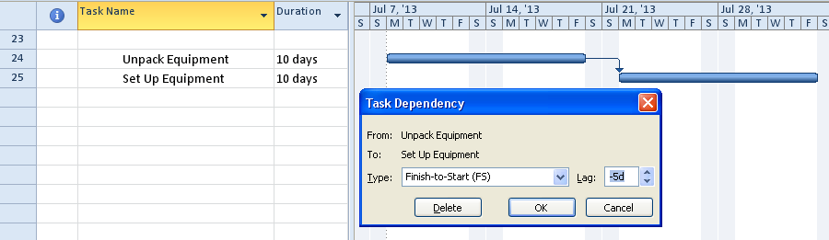

Below is the result of adding lead time between two tasks. Note the overlap of tasks and the total scheduling time has been shortened.

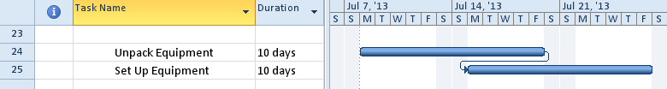

Lead time can also be expressed in percentages. The advantage to using percentages is if the predecessor task length changes, the successor task will automatically adjust its starting date.

For example:

* Task A is 10 days long and has a Finish-to-start relationship with Task B with -50% lead time
* Task B will is scheduled to start when Task A has 5 days of work completed
* Task A is taking longer than expected and is now scheduled to take 15 days
* Task B will be rescheduled to start when Task A has 7.5 days of work completed.

A -50% would move the successor task to the left 50% of the duration of the predecesser task. The diagram below demonstrates the result of applying -50% for Lead time to the relationship between these two tasks.

To enter Lead time between two tasks as a percentage value:

* Double click the relationship line between tasks where lead time is required.
* Enter “-50%” in the Lag field value
* Click OK to close the box



## Best Practices



Use Lag time when extending the timeline without adding cost or work to the project.

Best practices for the use of **Lag** time in a project schedule:

* Time must go by without a work or cost applied to the time. Lag is considered to be wait time like a delivery of equipment or concrete hardening
* Adding slack into the schedule to extend the timeline to allow for possible contingencies
* Adding wait time between phases of a project
* Adding wait time between parallel sections of a project to allow others to catch up
* Lag time may also be expressed in elapsed time to allow nights and weekends to be included
* Planning the work for a factory crew. For example: the crew needs to be at work for 9 hours but 8 of that is actual work. The remaining hour is meal and breaks. Use Lag to extend the time for the work of the crew to accommodate breaks.

Use lead time when the schedule needs to be shortened. More resources will be needed to accomplish the tasks. Lead time can increase risk of re-work and could increase cost for tasks.

Best practices for the use of **Lead** time in a project schedule:

* Piece work – when X number of items or time has been completed, giving the completed work to the next group to start their work.
* Testing – when X percentage of the testing is completed and successful, giving the completed work to the next group to start their work.
* When it is not necessary for the predecessor task to achieve 100% completion before starting the successor task.

## Practice: Working with Leads and Lags



*The Practice page is where you write detailed instructions for completing work listed as Exercises.*

*Type the Exercise Title and write a brief summary what the student will be doing in the exercise. Then list your ideas what they will be doing.*

*SAMPLE*

*In this practice you will create a Project Server Authentication profile and then configure the local cache settings in Project Professional 2007.*

*Exercise 1: Create Project Server Authentication Profile*

*In this exercise you will create Project Server authentication profile to connect to the Project Web Access site.*

Perform the following exercise on the PS07 virtual machine.

1. *From the* ***Start*** *menu, click* ***All Programs*** *🡪* ***Microsoft Office*** *🡪* ***Microsoft Office Tools*** *and click* ***Microsoft Office Project Server 2007 Accounts****.*
2. *In the* ***Project Server Accounts*** *dialog box, click* ***Add****.*
3. *In the* ***Account Properties*** *dialog box, and complete the following settings and click* ***OK****.*

|  |  |
| --- | --- |
| *Setting* | *Perform the following:* |
|  | |
| *Account Name* | *Type* ***Project Server*** |
| *Project Server URL* | *Type* ***http://epm/pwa*** |
| *When connecting* | *Select* ***Use Windows user account*** |
| *Set as default account* | *Select check box* |

# Summary



Turning a Work Breakdown Structure (WBS) into a project schedule is usually a team effort lead by the project manager. To help create a project schedule, Project 2010 has created flexiable scheduling capabilities offering manual and automatic scheduling modes. Task dependencies must be created to change a task list into a dynamic schedule. Lead and lag adjustments help refine the timeline for the project schedule.

Topics that were discussed:

1. Manual vs. Automatic Scheduling
2. Sequencing
3. Dependencies
4. Lag and Lead Time